C7_1

setwd(".")  
library(knitr)  
  
n<-30  
x<-780  
sigma<-40  
z<- -1.96

Apartado A

Liminf<- x+z*sigma/sqrt(n)  
Liminf

## [1] 765.6862

Limsup<- x-z*sigma/sqrt(n)  
Limsup

## [1] 794.3138

Apartado C

qnorm(0.005)

## [1] -2.575829

z99<--2.5758  
mu<--1*(sigma/sqrt(n))*z+x  
mu

## [1] 794.3138

k<-x-mu  
k

## [1] -14.31382

Muestra<-(z99*sigma)/k  
Muestra<-Muestra^2  
Muestra #La muestra debe ser de tamaño 51

## [1] 51.81236

Apartado E

xm<-seq(650,910,10)  
xpol<-seq(Liminf,Limsup,1)  
y<-dnorm(xm, x, sigma)  
ypol<-dnorm(xpol, x, sigma)  
xpol<-c(xpol,Limsup,Liminf)  
ypol<-c(ypol,0,0)  
  
plot(xm, y, type="l", col="red", lwd=2, xlab="Densidad")  
abline(v=780, col="black", lwd=2)  
polygon(xpol, ypol, col="grey", density=35)  
grid()

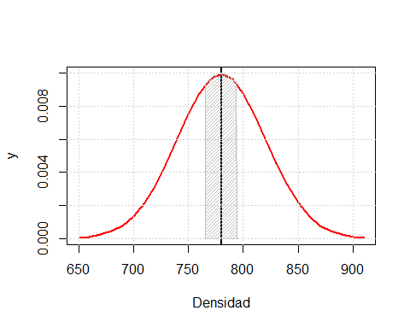

Conclusiones